Name:P.Jeeva
Reg No:192412636
Course Code:ITA0609
1. Problem Statement
Recruitment is a critical process in every organization. Ideally, hiring decisions should depend only on a candidate's qualifications, experience, and skills. However, gender bias can unintentionally influence recruitment, resulting in unequal employment opportunities. Historical hiring records may contain hidden biases, and if Machine Learning models are trained on such data without proper fairness checks, they may continue discriminatory hiring practices.
This project proposes a Machine Learning-based framework to detect gender bias in recruitment data. The system evaluates recruitment decisions using fairness metrics and identifies whether candidates of different genders receive unequal treatment despite having similar qualifications. By detecting these biases, organizations can improve transparency, fairness, and equal employment opportunities.
Objectives
- Detect gender bias in recruitment decisions.
- Compare hiring outcomes across different genders.
- Build a fair Machine Learning classification model.
- Recommend strategies to reduce discrimination.
- Support United Nations SDG 5: Gender Equality.

2. Background Study
Machine Learning is widely used in Human Resource (HR) departments for:
- Resume screening
- Candidate ranking
- Interview scheduling
- Employee selection
- Talent acquisition
Although ML increases recruitment efficiency, it also introduces ethical challenges. If historical hiring data contains gender discrimination, the model may learn biased patterns and unfairly reject qualified candidates.
Several organizations now employ Fair AI techniques that continuously monitor recruitment decisions for fairness using explainable Machine Learning models.
Machine Learning Challenges
- Historical bias in recruitment data
- Imbalanced datasets
- Missing candidate information
- Ethical and legal concerns
- Model transparency
- Fairness evaluation

3. Identification of the Learning Problem
Learning Type
Supervised Learning (Binary Classification)
The model predicts whether a candidate will be selected.
Input Features
- Gender
- Age
- Education Level
- Years of Experience
- Technical Skill Score
- Aptitude Test Score
- Interview Score
- Certifications
- Programming Skills
- Communication Skills
Target Output
Selected
- Yes
- No

Data Representation
Feature | Data Type
Gender | Categorical
Age | Numerical
Education | Categorical
Experience | Numerical
Technical Score | Numerical
Interview Score | Numerical
Communication Score | Numerical
Selected | Target Variable

4. Data Collection and Preparation
Dataset
The recruitment dataset contains candidate information collected from hiring records.
Example attributes include:
- Candidate ID
- Gender
- Education
- Experience
- Skills
- Interview Score
- Final Hiring Decision
Data Preprocessing
The preprocessing stage improves data quality.
Steps include:
- Removing duplicate records
- Handling missing values
- Encoding categorical variables
- Feature scaling using StandardScaler
- Outlier detection
- Feature selection
- Splitting dataset into training (80%) and testing (20%)
Libraries Used
- Pandas
- NumPy
- Scikit-learn
- Matplotlib

5. Selection of Machine Learning Approach
Chosen Algorithm: Decision Tree Classifier
Justification
Decision Tree is selected because:
- Easy to understand
- Produces interpretable rules
- Works well for classification
- Helps identify biased decision paths
- Requires minimal data preprocessing
- Supports explainable AI

6. Proposed Workflow
Recruitment Dataset
│
▼
Data Cleaning
│
▼
Data Preprocessing
│
▼
Feature Selection
│
▼
Train Decision Tree Model
│
▼
Predict Hiring Decision
│
▼
Fairness Evaluation
│
▼
Compare Male and Female Selection Rates
│
▼
Bias Detection
│
▼
Generate Recommendations

7. Algorithm Explanation
Decision Tree Algorithm
Step 1:
Load recruitment dataset.
Step 2:
Preprocess data by removing missing values.
Step 3:
Convert categorical variables into numerical values.
Step 4:
Split dataset into training and testing sets.
Step 5:
Train Decision Tree classifier.
Step 6:
Predict hiring decisions.
Step 7:
Compare predictions between male and female candidates.
Step 8:
Calculate fairness metrics.
Step 9:
Identify biased recruitment patterns.
Step 10:
Recommend corrective actions.

8. Sample Python Implementation
import pandas as pd
import numpy as np

from sklearn.model_selection import train_test_split
from sklearn.preprocessing import LabelEncoder
from sklearn.tree import DecisionTreeClassifier
from sklearn.metrics import accuracy_score

data = pd.read_csv("recruitment.csv")

encoder = LabelEncoder()

data["Gender"] = encoder.fit_transform(data["Gender"])
data["Education"] = encoder.fit_transform(data["Education"])

X = data[[
"Gender",
"Experience",
"InterviewScore",
"TechnicalScore"
]]

y = data["Selected"]

X_train, X_test, y_train, y_test = train_test_split(
X,
y,
test_size=0.2,
random_state=42
)

model = DecisionTreeClassifier()

model.fit(X_train,y_train)

prediction = model.predict(X_test)

accuracy = accuracy_score(y_test,prediction)

print("Accuracy =",accuracy)

9. Data Analysis Using NumPy and Pandas
Example analysis performed:
- Total candidates
- Male applicants
- Female applicants
- Selected candidates
- Rejected candidates
- Gender-wise hiring percentage
- Average interview score
- Average technical score
- Experience distribution
This analysis helps identify whether hiring decisions differ significantly between genders.

10. Visualization and Interpretation
Graph 1
Bar Chart
Gender vs Selected Candidates
Purpose:
Compare the number of selected male and female candidates.
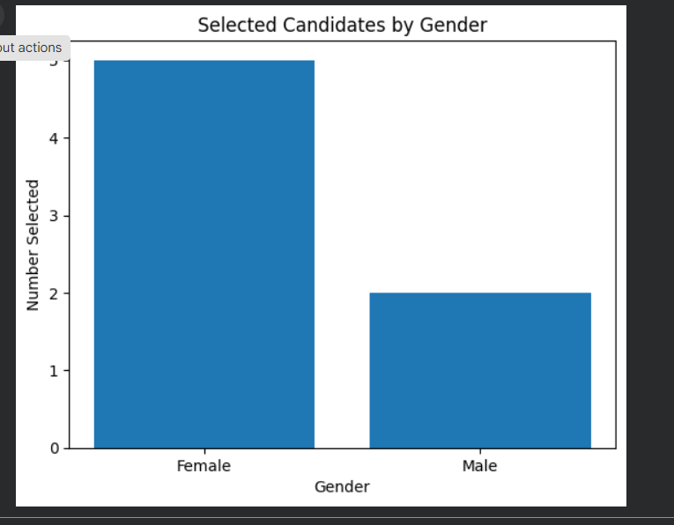

Graph 2
Pie Chart
Overall Recruitment Outcome
- Selected
- Rejected
- 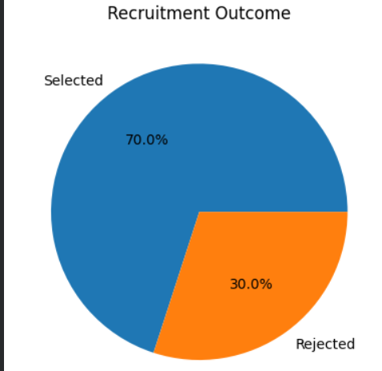

Graph 3
Histogram
Interview Score Distribution
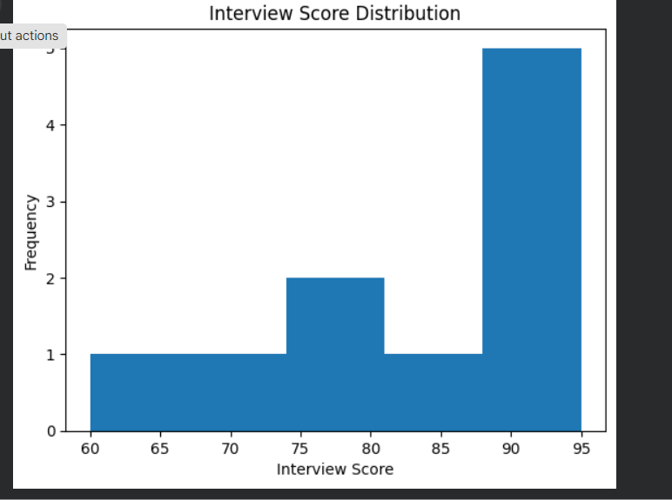

Graph 4
Box Plot
Experience vs Selection
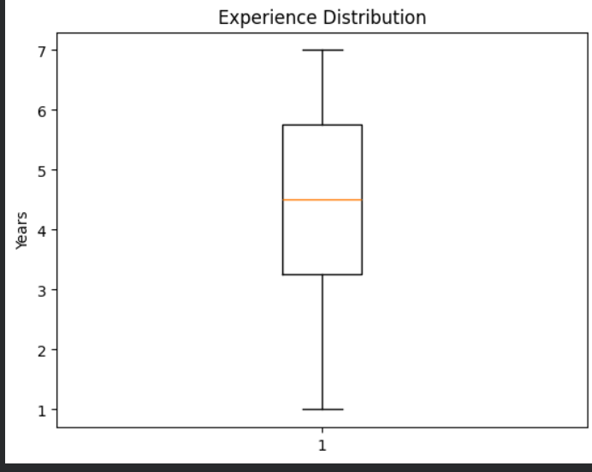

Interpretation
If candidates with similar qualifications receive different hiring outcomes based on gender, the recruitment process may contain bias. These visualizations help HR professionals identify and correct unfair hiring practices.

11. Expected Outcomes
The proposed model is expected to:
- Detect gender bias in recruitment
- Improve hiring transparency
- Support ethical AI
- Promote equal employment
- Increase fairness in hiring decisions
- Reduce discrimination

12. Advantages
- Fair recruitment process
- Transparent decision making
- Faster recruitment analysis
- Reduced human bias
- Easy interpretation
- Better compliance with employment laws
- Supports ethical Artificial Intelligence

13. Limitations
- Depends on dataset quality
- Historical bias may affect predictions
- Fairness metrics require continuous monitoring
- Sensitive personal information must be protected
- Cannot completely eliminate human bias

14. Practical Applications
Machine Learning fairness analysis can be used in:
- Corporate recruitment
- Government recruitment
- University campus placements
- Online job portals
- Human Resource Management Systems
- Public sector employment

15. Innovation and SDG Mapping
This work directly supports United Nations Sustainable Development Goal 5 (Gender Equality).
Innovation
- Automatic detection of gender bias
- Explainable Decision Tree model
- Fairness evaluation
- AI-assisted ethical recruitment
- Transparent hiring recommendations

SDG Contribution
- Equal employment opportunities
- Reduced workplace discrimination
- Inclusive hiring practices
- Ethical use of Artificial Intelligence
- Gender equality in organizations

16. Recommendations
To improve fairness in recruitment:
- Remove unnecessary gender information during resume screening.
- Use balanced datasets.
- Periodically audit Machine Learning models.
- Apply fairness-aware Machine Learning techniques.
- Monitor recruitment statistics regularly.
- Train HR professionals on ethical hiring practices.
- Review model predictions before final selection.

17. Conclusion
Machine Learning provides an effective solution for detecting gender bias in recruitment by analyzing hiring data objectively and identifying discriminatory patterns. Decision Tree models offer transparent and interpretable predictions, enabling organizations to evaluate recruitment fairness and take corrective actions. Incorporating fairness metrics, explainable AI, and regular audits ensures ethical recruitment practices while promoting SDG 5: Gender Equality. The proposed approach improves organizational transparency, builds public trust, and supports equal employment opportunities for all qualified candidates.

18. References
- Tom M. Mitchell, Machine Learning, McGraw-Hill Education.
- Ian Goodfellow, Yoshua Bengio, Aaron Courville, Deep Learning, MIT Press.
- Scikit-learn Documentation.
- Pandas Documentation.
- NumPy Documentation.
- United Nations Sustainable Development Goal 5 (Gender Equality

